Template 4 for OSPOR 2024
(Delete this textbox when you submit)
Arctic Meteorological and Geographical Observations on Dutch Whaling Vessels in 1758, 1759 and 1760

Gaston R. DEMARÉE¹, Yoshio TAGAMI², Pascal MAILIER¹, Astrid E. J. OGILVIE^{3,4}
and Takehiko MIKAMI⁵

¹Royal Meteorological Institute of Belgium, Brussels, Belgium
²Faculty of Human Development, University of Toyama, Toyama, Japan
³Stefansson Arctic Institute, Akureyri, Iceland
⁴Institute of Arctic and Alpine Research, University of Colorado Boulder, Colorado, U.S.A.
⁵Department of Geography, Tokyo Metropolitan University, Hachioji, Tokyo, Japan

(Received September XX, 202X; Revised manuscript accepted XXXX XX, 202X)

Abstract
Recently, snowstorms have become extremely severe in the Okhotsk Area of Hokkaido, Japan. They have ................................ and by the Civil Engineering Research Institute for Cold Region.

Key words: road, snowstorm countermeasure, snowbreak forest, snowstorm, traffic hindrance

1. Introduction
Hokkaido is designated as a snowy cold region, and the Okhotsk Area has particularly severe...........

2. Snowstorm damage in the Okhotsk area
2.1 Storm paths over Hokkaido
Low-pressure systems that bring heavy snowfall and snowstorms to Hokkaido have various characteristics, depending on their paths (Fukamachi et al., 2004).
There are three major types of low-pressure systems as shown in Fig. 1. ..........
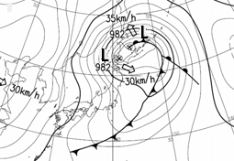
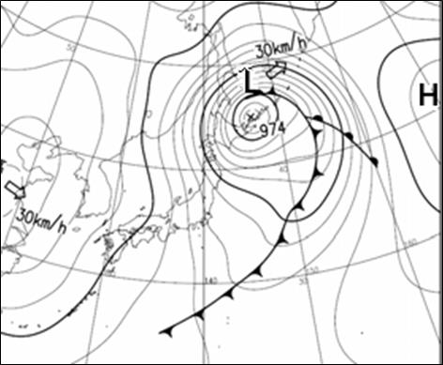
15:00, March 2, 2013

9:00, March 2, 2013

Fig. 1 Low-pressure system with two centers near the Okhotsk District

2.2 Snowstorms and road traffic hindrances in Okhotsk Area
Roads in Eastern Hokkaido are frequently closed due to blowing snow (Kawamura et al., 2007; Takahashi and Kosugi, 2010). ........ on national highways in Hokkaido (Fig. 2). ......

………………………………………….

5. Conclusion
This paper has explained road traffic disruption in the Okhotsk Area, which has particularly...........

References
Fukamachi, Y., G. Mizuta and 4 co-authors (2004): Transport and modification processes of dense shelf water revealed by long-term moorings off Sakhalin in the Sea of Okhotsk. J. Geophys. Res. 109: C09S10, doi:10.1029/2003/JC001906.
Ohshima, K.I., T. Watanabe and S. Nihashi (2003): Surface heat budget of the Sea of Okhotsk during 1987–2001 and the role of sea ice on it. J. Meteorol. Soc. Jpn., 81, 653-677.
Kawamura, K., F. Parennin and 16 co-authors (2007): Northern hemisphere forcing of climatic cycles in Antarctica over the past 360,000 years. Nature, 448, 912-916.
Takahashi, S. and T. Kosugi (2010): Sea-ice extent variations along the Okhotsk coast of Hokkaido and Shiretoko Peninsula’s ‘Dam Effect’ against sea ice flow. Proc. 25th Intnatl. Symp. on Okhotsk Sea & Sea Ice, Mombetsu, Japan, 25, 25–28.
If possible, add Japanese summary (5-20 lines) in the end of paper.

(If possible)
Summary in Japanese
和文要約
1760年前後のオランダ捕鯨船による
北極域の気象学的・地理学的観測
Gaston R. DEMARÉE¹, 田上善夫², Pascal MAILIER¹, Astrid E.J. OGILVIE^{3,4}, 三上岳彦⁵
¹ベルギー王立気象研究所, ²富山大学，³ステファンソン北極研究所,⁴コロラド大学ボルダー校, ⁵首都大学東京

捕鯨とニシン漁業は、オランダ黄金時代（1600-1800）の主要な経済活動の担い手であった。.........

Correspondence to: G. R. Demarée, xxxxx@yyyyy.zz

Copyright ©2024 The Okhotsk Sea & Polar Oceans Research Association. All rights reserved.

